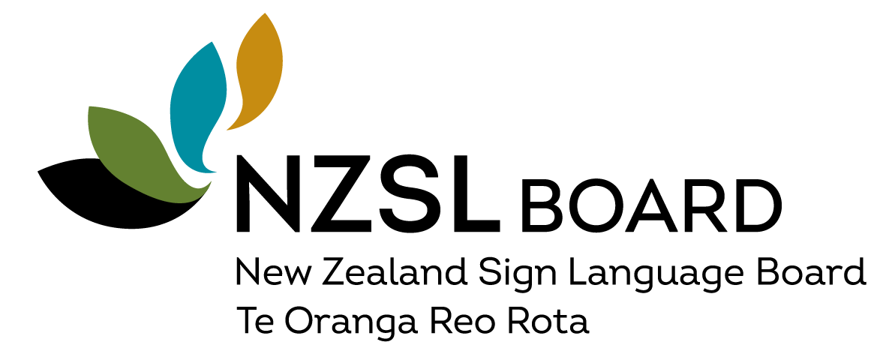

How to apply
- Please fill out all the questions in this form. These questions will help us to learn about you, and how you can support the NZSL Board.
- When the nomination checklist is completed, please email to nzsl@whaikaha.govt.nz
- You need to apply by 5pm on 14 February 2025. If you are late, we may not accept your application.
- We will email you updates. When we receive your application, Whaikaha will send an email reply to let you know about the process. If you are invited to have an interview, we will tell you what to expect and keep in touch through the process.
- If you have any questions, or need help with this process please email nzsl@whaikaha.govt.nz
- You can apply in English or NZSL. You can add YouTube links to your NZSL video under each question.

Nomination Checklist:
Please provide the following to complete the nomination process:
¨ A cover letter explaining your relevant skills and experience.
¨ A NZSL video submission (maximum of 3 minutes)
- Introduce yourself.
- Describe the current issues relating to the promotion and maintenance of NZSL.
¨ A completed Nomination Form (this form).
¨ A completed Cabinet Committee Curriculum Vitae (CAB 50/01).
¨ A completed Nominee Declaration Form.
¨ A completed Police vetting form.
- Complete page 3 and 4 of the form only.
- Email the form with 2 forms of ID – For NZ passport, can you please make sure the file that is sent include both the photo and signing pages.

Nominee details:
Name:
Email / phone:
Address:

Role the nomination is for: | Board Member
 | Board Chair
Deaf or hearing?
Fluent in New Zealand Sign Language?
Ethnicity identified with?

Do you know your iwi? If yes, please write the name(s) of your iwi below.

Contact details of two people who can act as a referee:
Contact One
Name:

Their relationship to nominee:

Contact details (telephone and email):

Contact Two
Name:

Their relationship to nominee:

Contact details (telephone and email):

