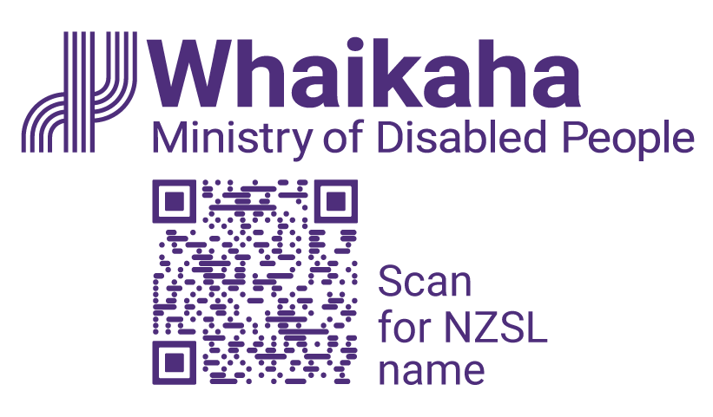This is the logo for the NZSL Board. It depicts four colorful leaves. 
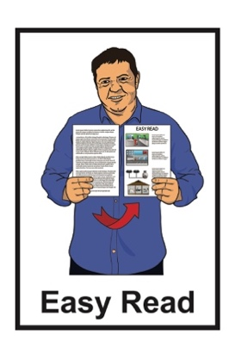

**Tell us what you think:   
The draft New Zealand   
Sign Language Strategy**

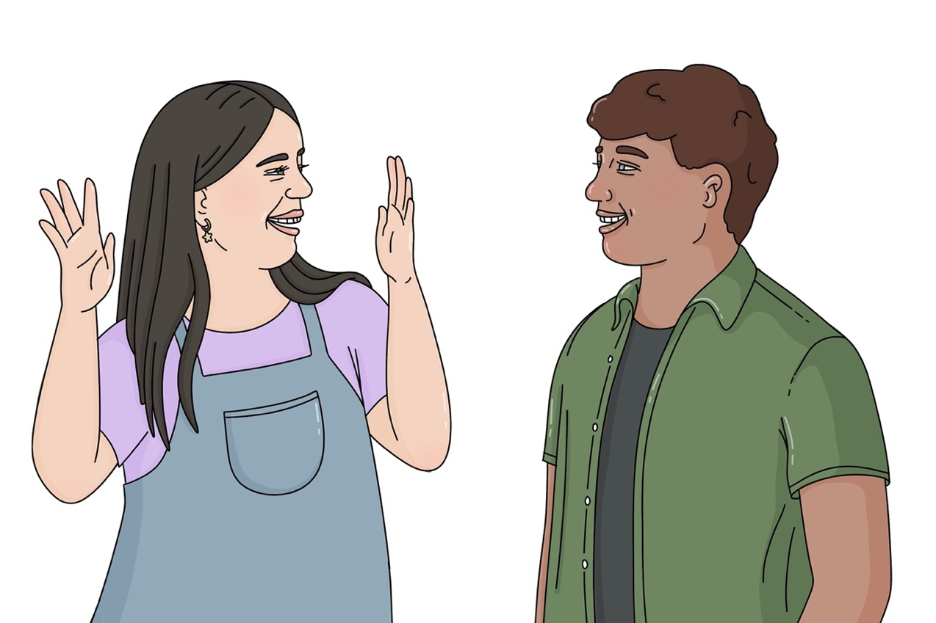**2025 to 2030**

Published: April 2025

# What is in this document

**Page number:**

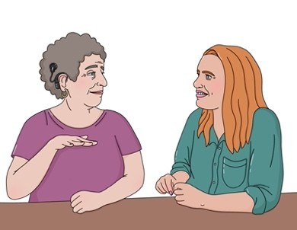

About this document 2

Questions 7

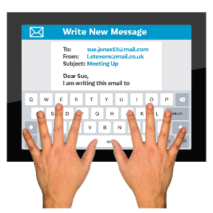

How to send your feedback to us 16

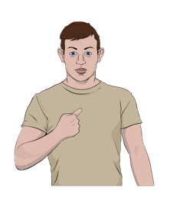

Keeping your information safe 19

# About this document

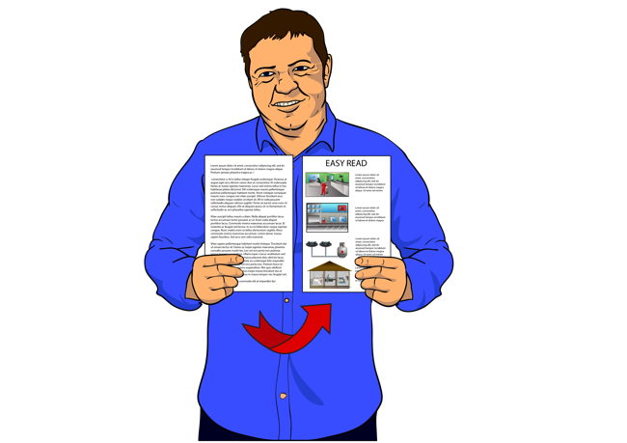

This document:

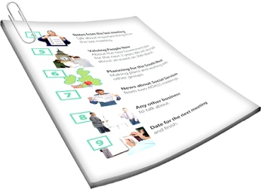supports you to give your feedback about the Easy Read **summary** of the **draft** of the full New Zealand Sign Language **Strategy**

is a **consultation** document.

A **summary**:

* is shorter than the main document

tells you the main ideas.



A **draft** is the first version of something like a document.

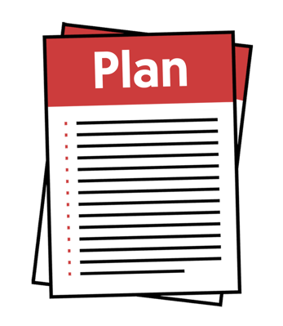Here a **strategy** is a set of long term plans that are made to reach a goal.



Here **consultation** is the different ways we find out what people think about the draft summary of the New Zealand Sign Language Strategy like:

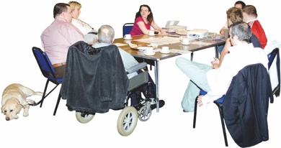meetings

interviews.

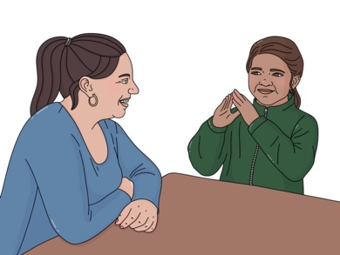

We call New Zealand Sign Language **NZSL** for short in this document.

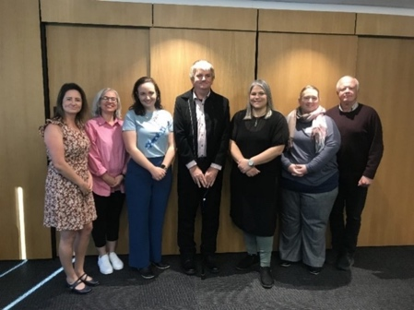This Easy Read document is   
from the:

**New Zealand Sign Language Board**

Ministry of Disabled People   
– Whaikaha.

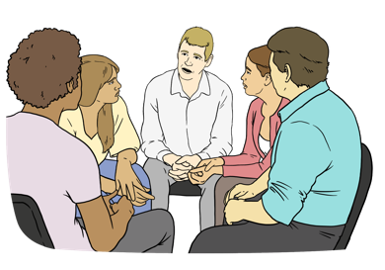The **New** **Zealand Sign Language** **Board** is a group of people.

Their job is to:

support people to know what NZSL is

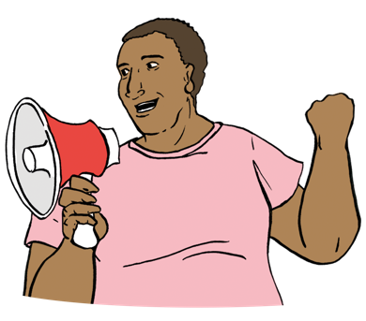make sure Deaf people can use NZSL in all parts of their life

give advice about NZSL to the:

* 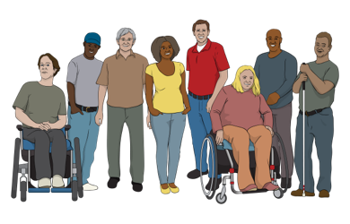Government
* community.



We call the New Zealand Sign Language Board the **NZSL Board** for short in this document.

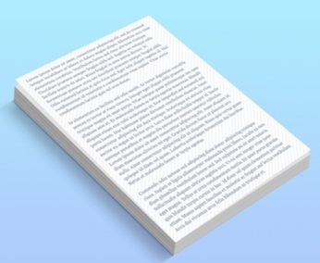When you see the words **we / us** in this document it means the   
NZSL Board.

The work of the NZSL Board is supported by the Ministry of Disabled People – Whaikaha.

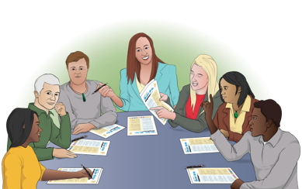

This year we are **updating** the   
New Zealand Sign Language **Strategy.**

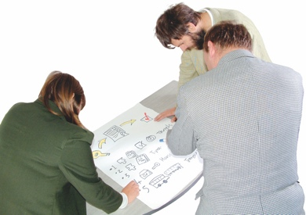**Updating** means looking at something to see what needs to be done to make it better like:

changing it

adding something.

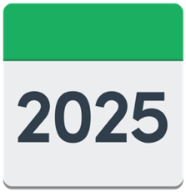

**2030z**

The new NZSL Strategy will guide our work from 2025 to 2030.

We want to find out what you think about the changes we want to make to the NZSL Strategy.

This Easy Read document supports you to do this.

The questions in this document will support you to tell us what you think.



You do not have to answer these questions.

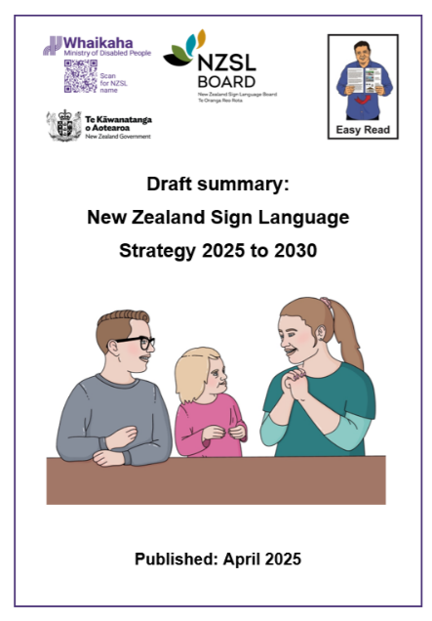

You can read the **draft** Easy Read **summary** of the new NZSL Strategy at this **website**:

[**www.nzsl.govt.nz**](http://www.nzsl.govt.nz/)

Go to **page 16** to find other ways you can give us feedback about the draft NZSL Strategy.

# Questions



What you think about our draft NZSL Strategy is important to us.



We have made some questions to support you to tell us what you think.



You do not have to answer all the questions.

You can:

use this document to write down your thoughts before you give us your feedback in a different way

**or**

answer the questions as part of your feedback.

On **page 16** we tell you:

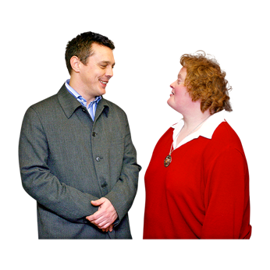other ways to let us know what you think about the NZSL Strategy

how to send your feedback.

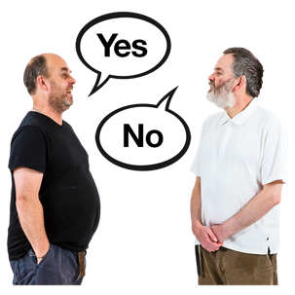Do you agree with the changes we would like to make to the   
NZSL Strategy?

Write your answer in this box.

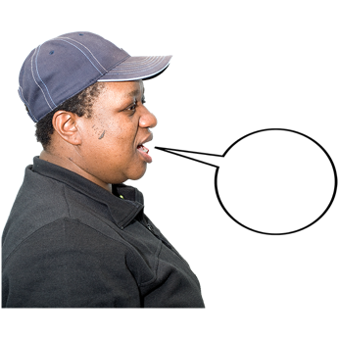

Tell us how you think we could make these changes better.

Write your answer in this box.

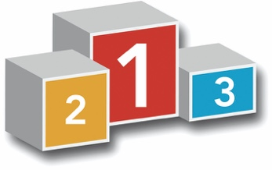Do you think the 5 priority work areas will support NZSL to grow?



Write your answer in this box.



How do you think these 5 priority work areas could be made better?



Write your answer in this box.

Do you agree with the actions we have made for each of the 5 priority work areas?



Write your answer in this box.



Tell us the reasons why you think the actions are:

good ideas

bad ideas.



Write your answer in this box.

What other actions should we think about having in the NZSL Strategy?

Tell us why you think this.



Write your answer in this box.

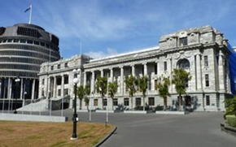

What do government agencies need to think about?

Tell us why you think this.



Write your answer in this box.

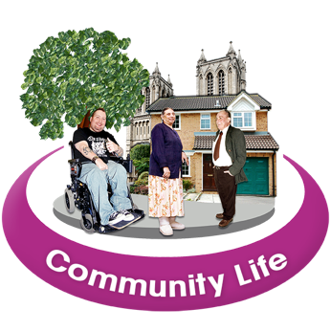Communities will need to do some of the actions in the NZSL Strategy like the:

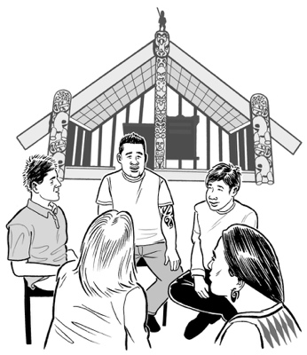Deaf community

Turi Māori.

What do communities need to think about to do this?



Write your answer in this box.

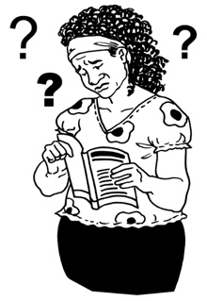What are the main barriers you have come up against when trying to get things like services in NZSL?



Write your answer in this box.



What do you think are the most important areas to make changes to?



Write your answer in this box.

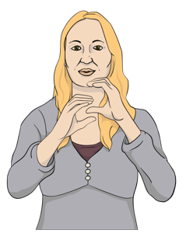How do you think we will know   
if the new NZSL Strategy   
is working?



Write your answer in this box.

# How to send your feedback to us

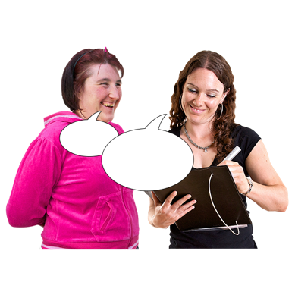

This part of the document tells you how to give us your feedback about the NZSL Strategy.

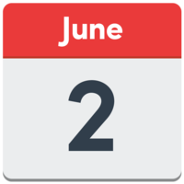

The closing date to send us your feedback is **2 June 2025**.



You can give us feedback by going to:

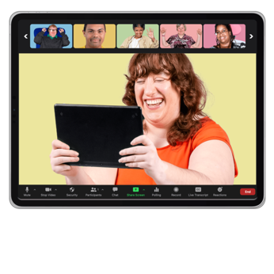in person meetings

online meetings.

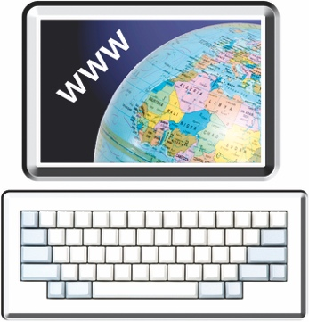You can find more information about these meetings at the NZSL Board **website**:

[**www.nzsl.govt.nz**](http://www.nzsl.govt.nz/)

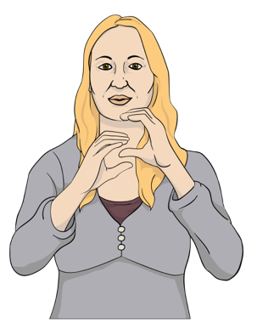You can also give us your feedback in:

NZSL in a video

writing.

You can send us a copy of your answers to our questions.



Send your feedback to this **email** address:

[**nzsl_strategy@whaikaha.govt.nz**](mailto:nzsl_strategy@whaikaha.govt.nz)



You can also complete an online form at this website:

[**www.nzsl.govt.nz**](http://www.nzsl.govt.nz/)

You can **email** the NZSL team for more information about the consultation process here:

[**nzsl_strategy@whaikaha.govt.nz**](mailto:nzsl_strategy@whaikaha.govt.nz)

# Keeping your information safe

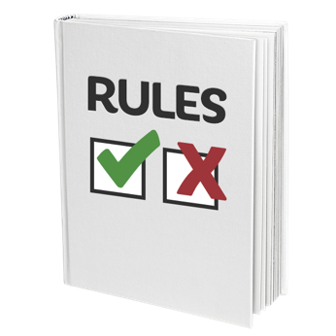

We follow what the **Official Information Act** says about what to do with the information you send us.

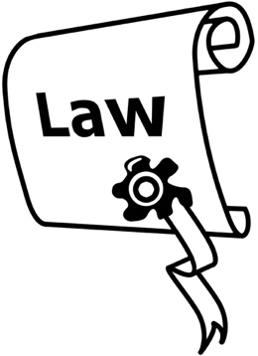

The **Official Information Act** is a law that sets out the rules on how to keep information held by the Government.



Anyone can ask to see the feedback we get from our consultation.

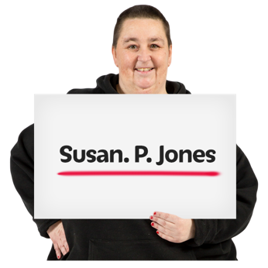

If this happens we will take out all your **personal information** before we give it to them.

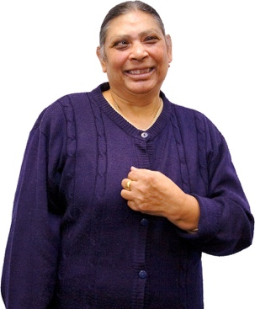Here your **personal information** can be things like your:

name

address.



Please tell us if you do not want us to give your information to somebody else.

This information has been written by the NZSL Board and the Ministry of Disabled People – Whaikaha.

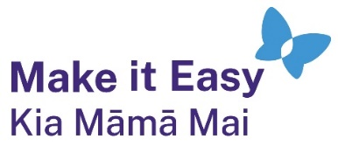It has been translated into Easy Read by the Make it Easy Kia Māmā Mai service of People First New Zealand Ngā Tāngata Tuatahi.



The ideas in this document are not the ideas of People First New Zealand Ngā Tāngata Tuatahi.



All images used in this Easy Read document are subject to copyright rules and cannot be used without permission.

Make it Easy uses images from:

* Photosymbols
* Change Images
* Huriana Kopeke-Te Aho



* SGC Image Works
* T Wood
* Studio Rebeko
* Inga Kramer.