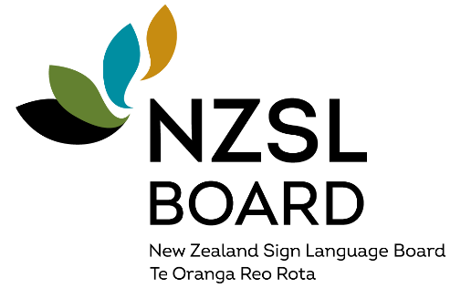
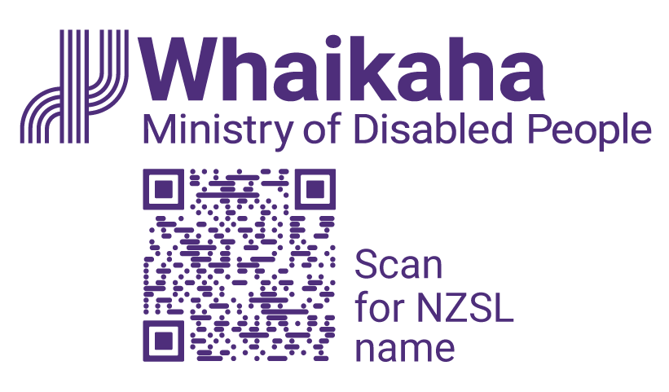
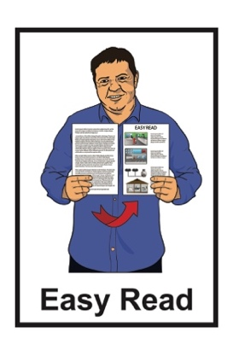

Draft summary:
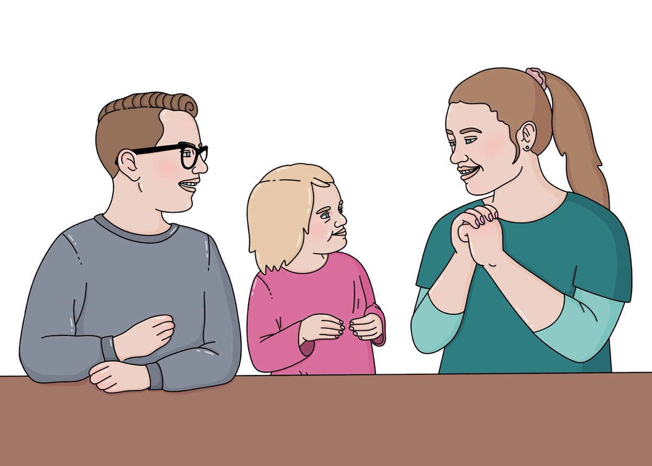
New Zealand Sign Language Strategy 2025 to 2030

Published: April 2025

Before you start

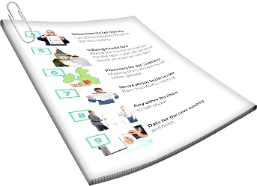
This is a long document.


It can be hard for some people to read a document this long.

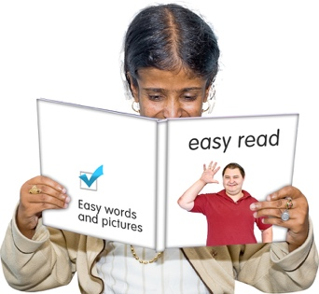
Some things you can do to make it easier are:
read it a few pages at a time
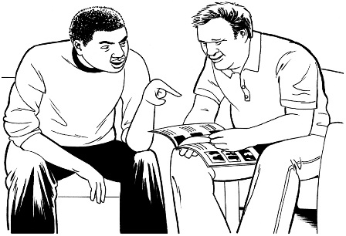
set aside some quiet time to look at it
have someone read it with you to support you to understand it.

What is in this document

Page number:
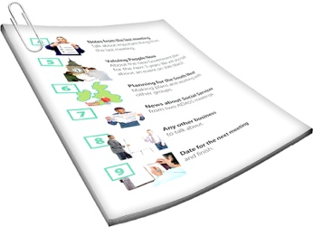

About this document 4
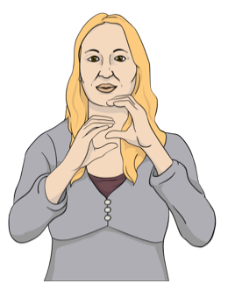

New Zealand Sign Language –everywhere and every day 9

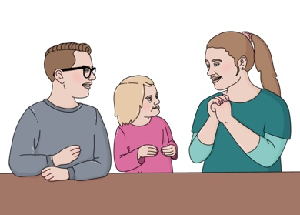
About NZSL 12

The Deaf community 15


Why an NZSL Strategy
is important 20

Page number:
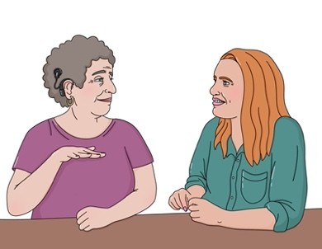

What should happen to make
life better for Deaf people 23
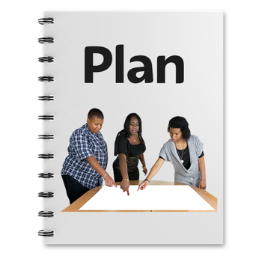

How we plan to update
the NZSL Strategy 28

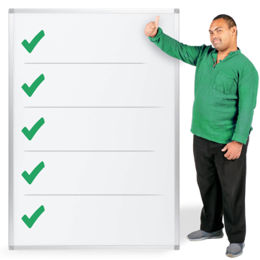
5 priority areas of work 31

Action plan 57

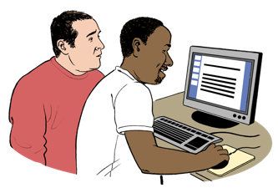
How to send your feedback to us 62

About this document

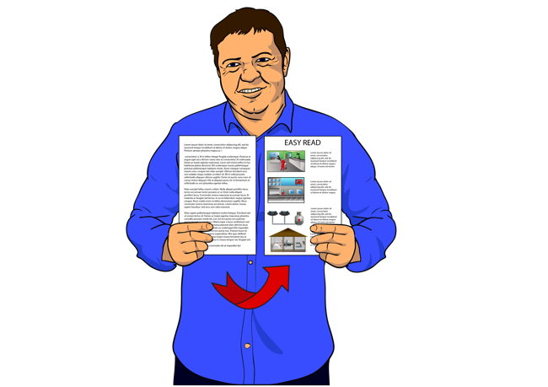
This document is:
an Easy Read summary of the draft of the full New Zealand Sign Language Strategy
a consultation document.


A summary:
- is shorter than the main document
tells you the main ideas.

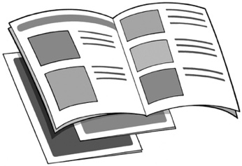
A draft is the first version of something like a document.

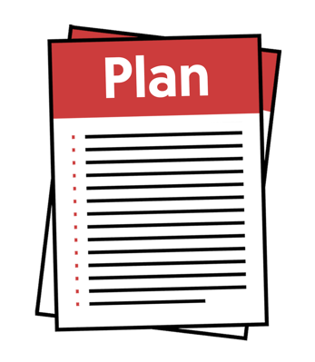
Here a strategy is a set of long term plans that are made to reach a goal.

Here consultation is the different ways we find out what people think about this draft summary of the New Zealand Sign Language Strategy like:
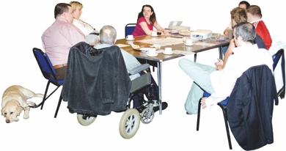
meetings
interviews.

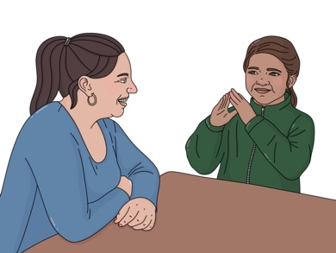

We call New Zealand Sign Language NZSL for short in this document.

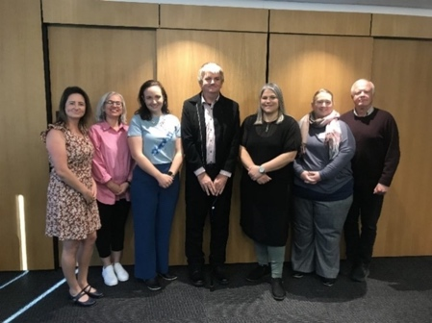
This Easy Read document is
from the:
New Zealand Sign Language Board
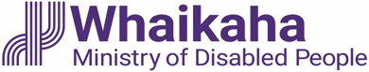
Ministry of Disabled People
– Whaikaha.
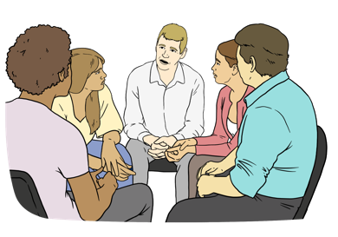
The New Zealand Sign Language Board is a group of people who:
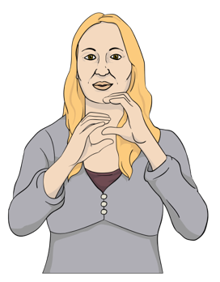
have lived experience of using NZSL
know a lot about NZSL
give advice about NZSL to the:
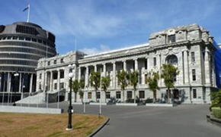
- Government
- community.

We call the New Zealand Sign Language Board the NZSL Board for short in this document.


When you see the words we / us in this document it means the
NZSL Board.

The work of the NZSL Board is supported by the Ministry of Disabled People – Whaikaha.

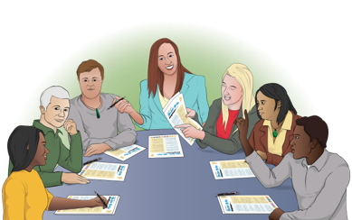
This year we are updating the
New Zealand Sign Language Strategy.

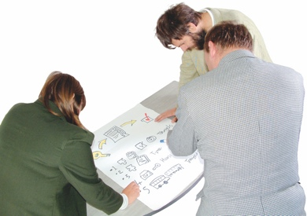
Updating means looking at something to see what needs to be done to make it better like:
changing it
adding something.

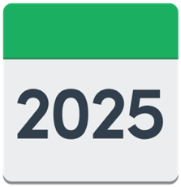
2030z
The new NZSL Strategy will guide our work from 2025 to 2030.


This document tells you about the changes we want to make to the NZSL Strategy.

We want to know what you think about the changes we want to make to the NZSL Strategy.

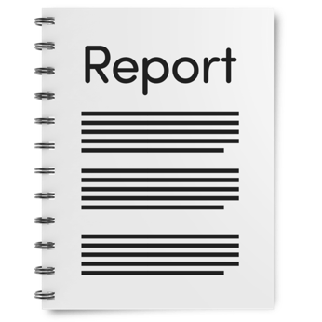
You can read the full report at this website:

www.nzsl.govt.nz

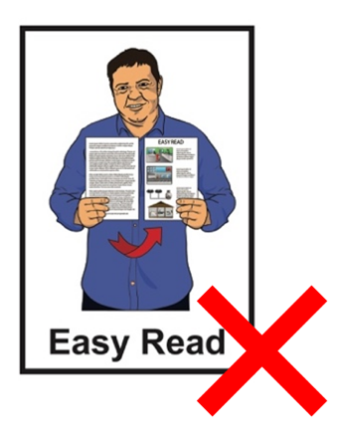
This full report is not in Easy Read.

New Zealand Sign Language –
everywhere and every day

We want everyone to:
know about NZSL

use NZSL
accept NZSL as an official language.

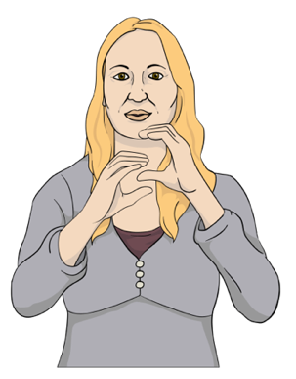
An official language means that:
it is protected by the Government
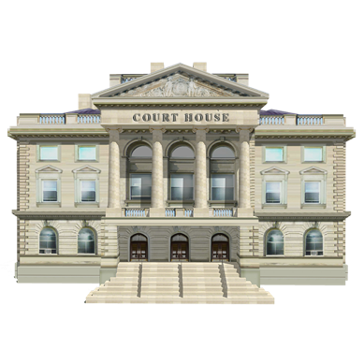
people are supported to use it
it can be used in places like the courts.


Supporting New Zealanders to learn more about NZSL will assist more people to use NZSL.

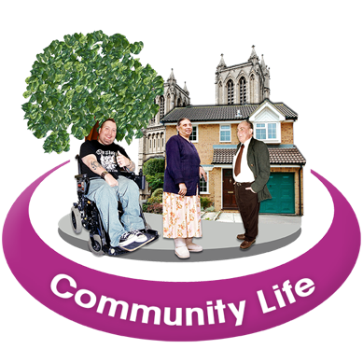
We want deaf / hard of hearing people to be able to take part in their:
whānau / family life
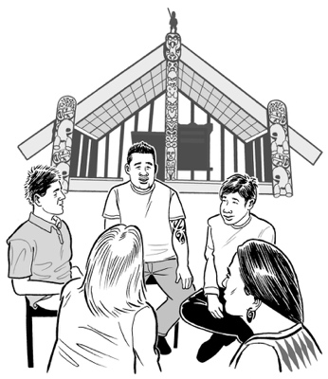
community life
cultural life.

Cultural means where a group of people share the same things like:
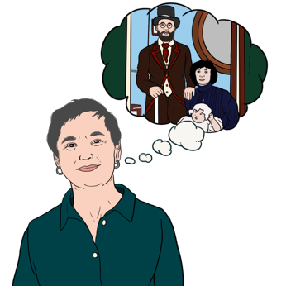
language like NZSL
experiences
history.

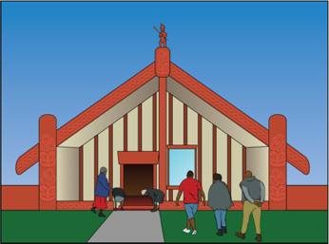
We want Turi Māori to be able to take part in te ao Māori.

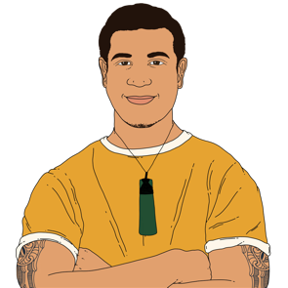
Turi Māori are Māori who are deaf / hard of hearing.

Te ao Māori is the Māori world.

About NZSL

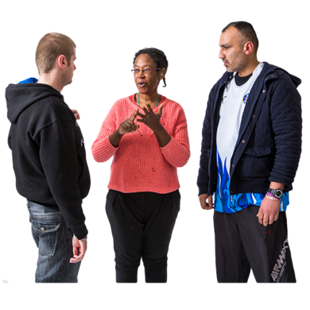
NZSL is:
an important part of Deaf culture
the language deaf people use.

deaf
When you see the word deaf with a small d this means it is something about audiological deafness.

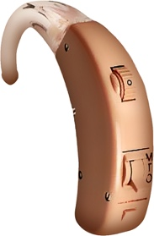
Audiological deafness is about hearing loss like when a person:

has some hearing loss
has a lot of hearing loss
cannot hear anything.

When you see the word Deaf with a capital / big D it means:
Deaf
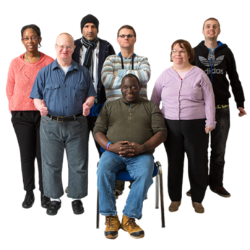
Deaf culture
the Deaf community.

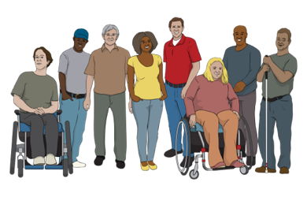
The Deaf community:
use NZSL as their first language
is a cultural group.

We want all New Zealanders to know that NZSL is an official language.
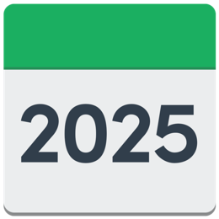
2006

NZSL was made an official language in 2006.


Not many people use NZSL.


Only half a percent of people here in Aotearoa New Zealand use NZSL.

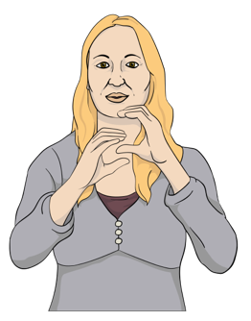
This means we are in danger of losing NZSL.

We need to grow the language to make sure we do not lose NZSL.

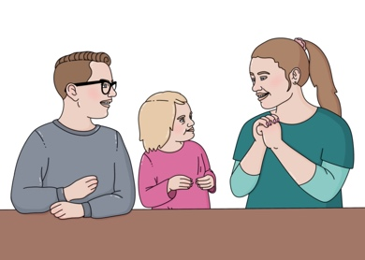
To do this we need more people to use NZSL.

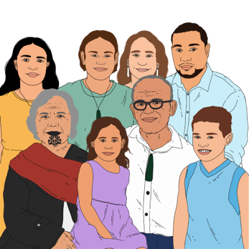
To grow NZSL we need support from:
the hearing community
iwi / tribes

whānau / families
everyone.

The Deaf community

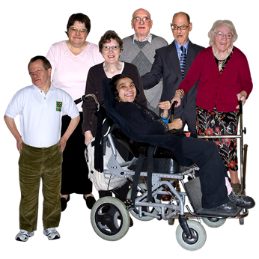
The Deaf community in Aotearoa New Zealand is made up of many different groups of people.

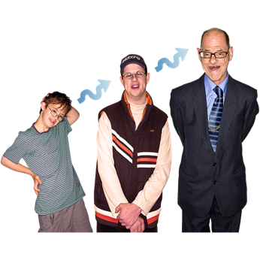
Deaf people:
are different ages
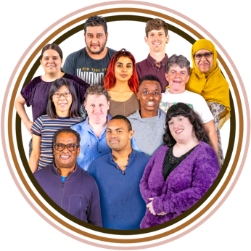
are from different ethnicities
have different levels of hearing loss.

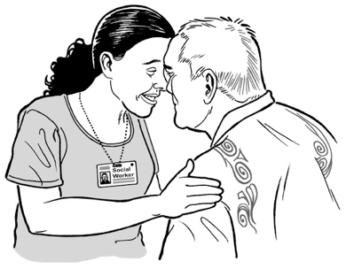
Ethnicity is the group a person belongs to that shares some of the same things like:
language
cultural background.
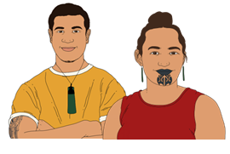
There are many different groups within the Deaf community like:
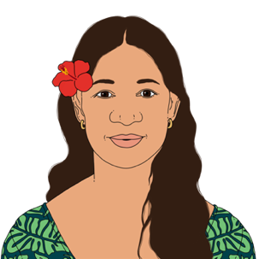
Turi Māori
Māori
Pasifika peoples

Rainbow communities
Deaf+ who are Deaf people with an extra disability
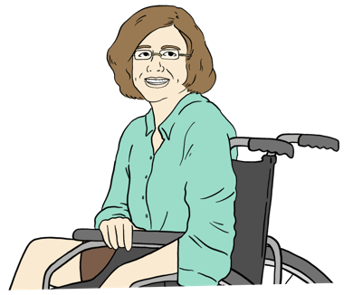
disabled people.

There is also a deafblind community.

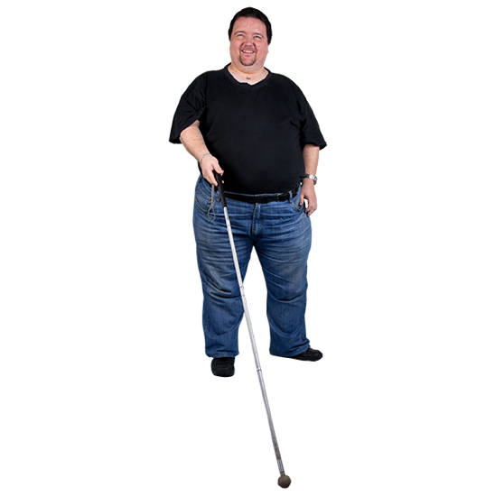
People who are deafblind are:
deaf
and
blind.
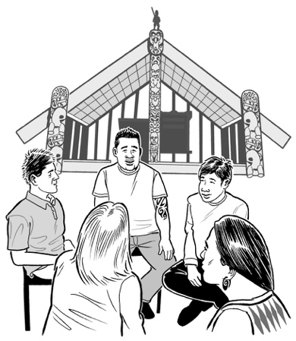
We accept Turi Māori are tangata whenua / first people of
Aotearoa New Zealand.

Many Turi Māori see themselves as:
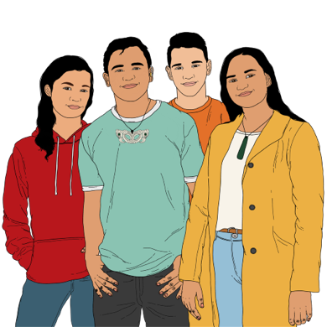
Māori
and
members of the Deaf community.

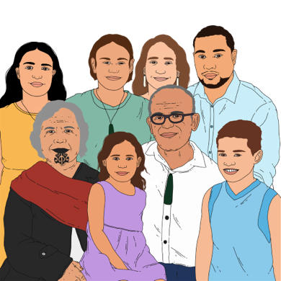
It is important for Turi Māori to be able to take part in both these worlds.

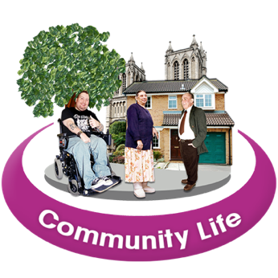
Deaf people are also part of other communities like the:
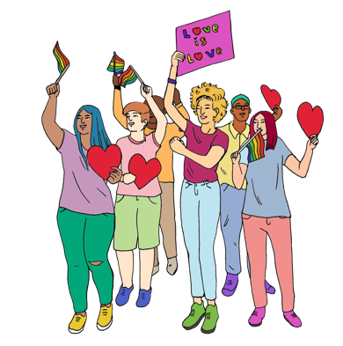
disability community
Rainbow community.

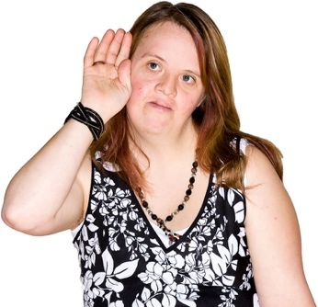
Other people who are not part of the Deaf community can be a link between the:
hearing community
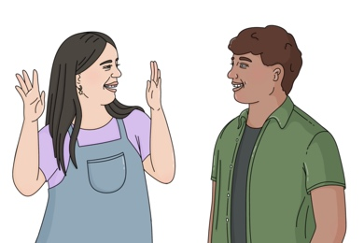
and
Deaf community.

These are people like:
NZSL interpreters
whānau / families of Deaf people.

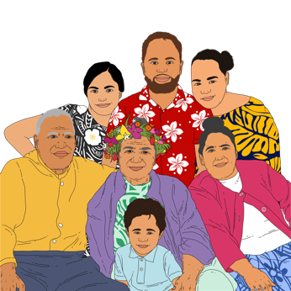
Most deaf tamariki / children are born into hearing families.

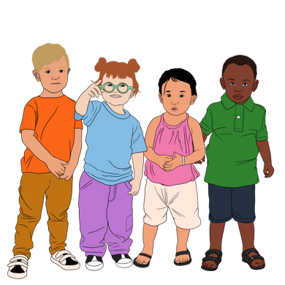
It is important to have a link between the Deaf and hearing communities to support:
deaf tamariki / children

and
their whānau / families.

Why an NZSL strategy is important

Our job as the NZSL Board is to:
support people to know what NZSL is
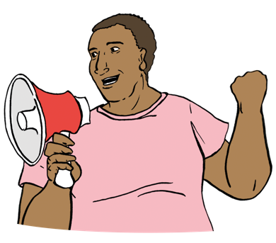
make sure Deaf people can use NZSL in all parts of their life
give advice about NZSL to the:
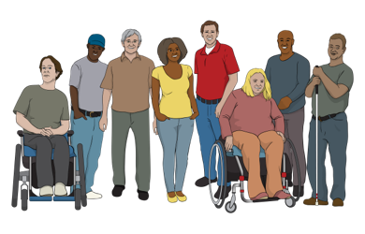
- Government
- community.
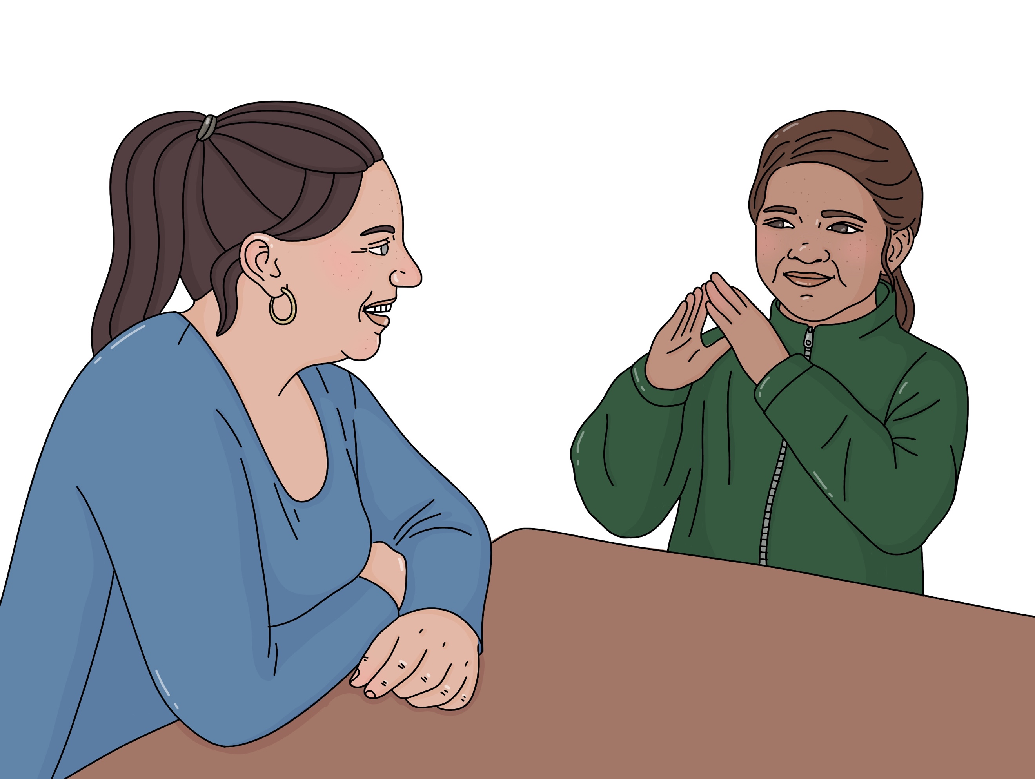

Having an NZSL Strategy supports us to do our job.
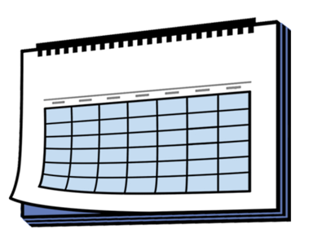

The new NZSL Strategy will guide our work for the next 5 years.


It will also support our decisions about what things to fund to support NZSL.

Our decisions will be based on what the NZSL Strategy says.

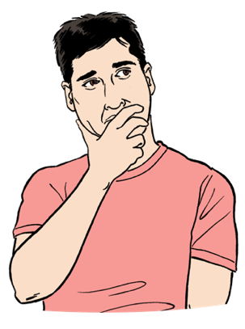
We want to know what you think about the ideas in this draft NZSL Strategy.

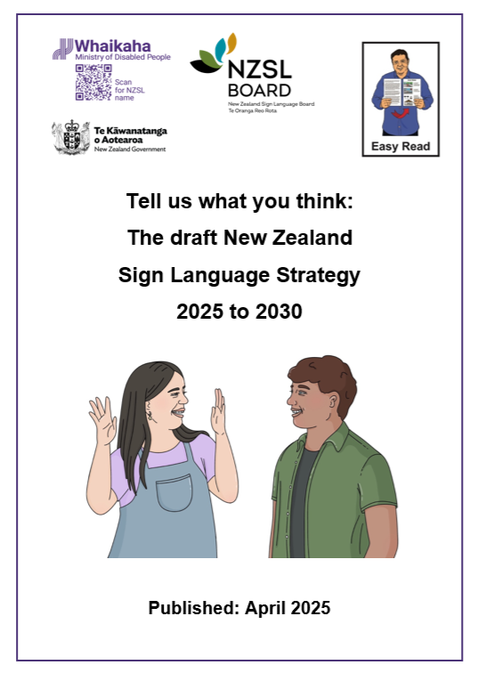
We have made another Easy Read document to support you to give us your feedback called:

Tell us what you think: The draft New Zealand Sign Language Strategy 2025 to 2030.

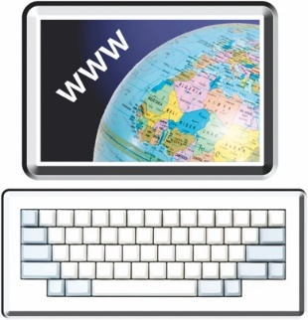
You can read it at this website:

www.nzsl.govt.nz

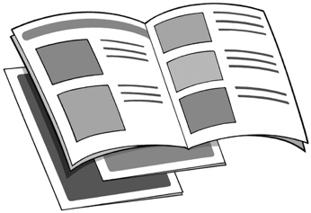
To find out how to give your feedback go to page 62.

What should happen to make life

better for Deaf people

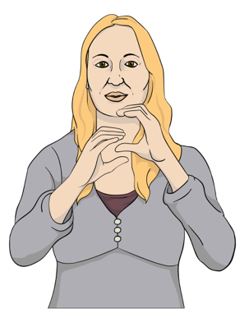
Government agencies have very little information about the lives of
New Zealanders who are:
deaf
hard of hearing.

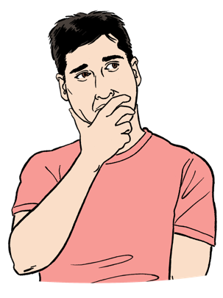
This means government agencies do not know what they need to do to make their services better for the Deaf community.

It is important to find out what is happening in the lives of deaf / hard of hearing people.

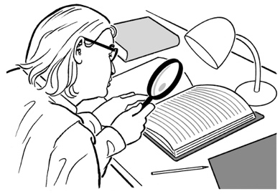
Research tells us the lives of deaf / hard of hearing people are harder than the lives of hearing people.

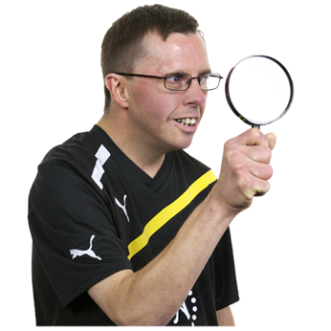
Here research means someone:
looks at what has happened
tries to find ways to do things better.


Research other countries have done show learning a sign language like NZSL early in life:

is very important
supports deaf people to have a good life.

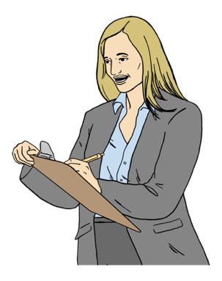
This means finding out what barriers deaf / hard of hearing people experience in their daily lives.

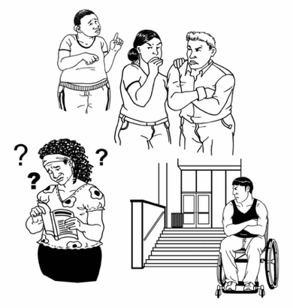
A barrier is something that stops a person doing something they:
want to do
need to do.

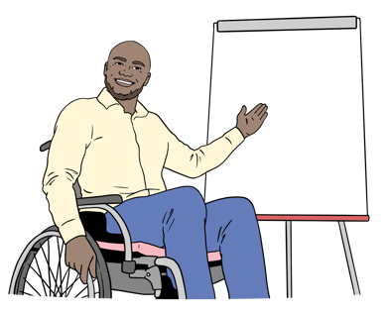

Deaf people along with their whānau / families find it hard to do things like:
learn NZSL
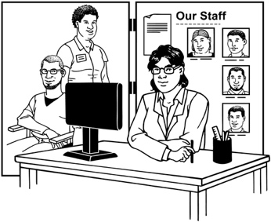
use NZSL in everyday life
get the information they need in NZSL.


Supporting NZSL is an important way to assist deaf / hard of hearing people to live good lives.

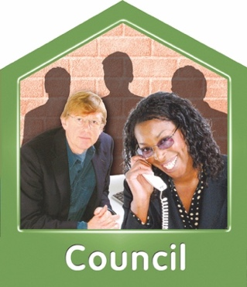
Deaf / hard of hearing people find it hard to get services in NZSL from:
their local government like the council
government agencies.


Deaf people face many barriers to getting education in NZSL here in
Aotearoa New Zealand.

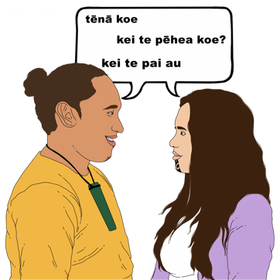

Turi Māori also face many barriers to being able to take part in te ao Māori.

For example there are not many NZSL interpreters who speak
te reo Māori fluently.

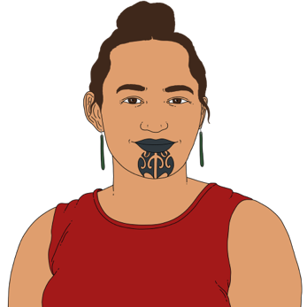
Here fluently means you can speak a language like te reo Māori:
easily
quickly.

How we plan to update the
NZSL Strategy

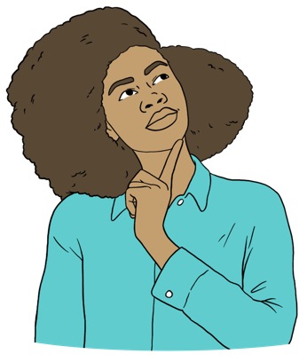
Our vision is NZSL everywhere and every day.

Here vision is how we imagine NZSL will be used in the future.

The 2 main ways we want to update the NZSL Strategy are:
revitalisation
integration.

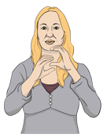
Here revitalisation means supporting NZSL to:
grow
be used by more by everyone.
Here integration means getting hearing people:

to learn NZSL
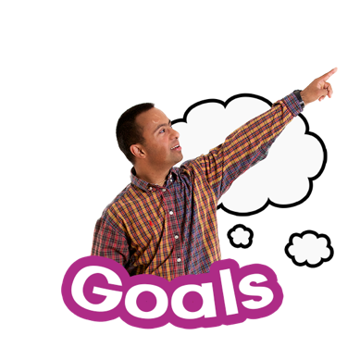
use NZSL every day.

Revitalisation


The main goals of revitalisation are to make sure NZSL:
survives
thrives.



Here thrive means NZSL is:
growing well
being used by lots of people.

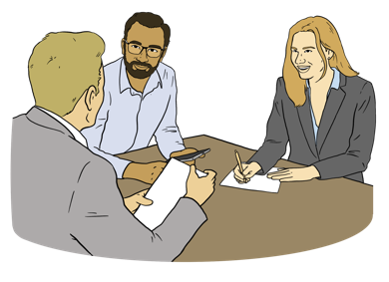
We will work closely with the Deaf community to be able to revitalise NZSL.

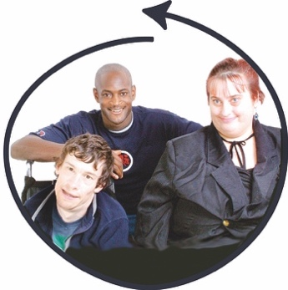
Integration

We want NZSL used every day and everywhere by all New Zealand:
children
adults.

This means we want people in the hearing community to
learn NZSL
use NZSL.
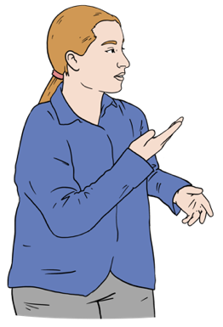

Doing this supports the integration of NZSL into everyday language here in Aotearoa New Zealand.

5 priority areas of work

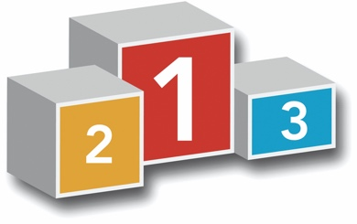

Here priority means the most important areas of work we need to do to:
revitalise NZSL
integrate NZSL.

There will be 5 priority work areas in the NZSL Strategy.


There are actions in each priority work area.
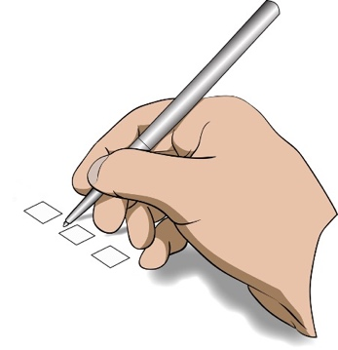

Here actions are the different jobs to be done in each priority work area.

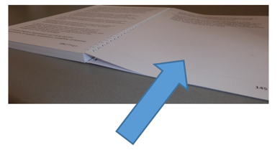
There is a picture on the next page to explain the NZSL Strategy.

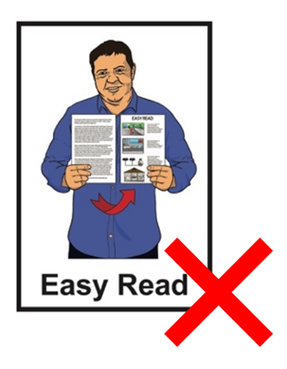
It is not in Easy Read.

Turn this page on its side to read.
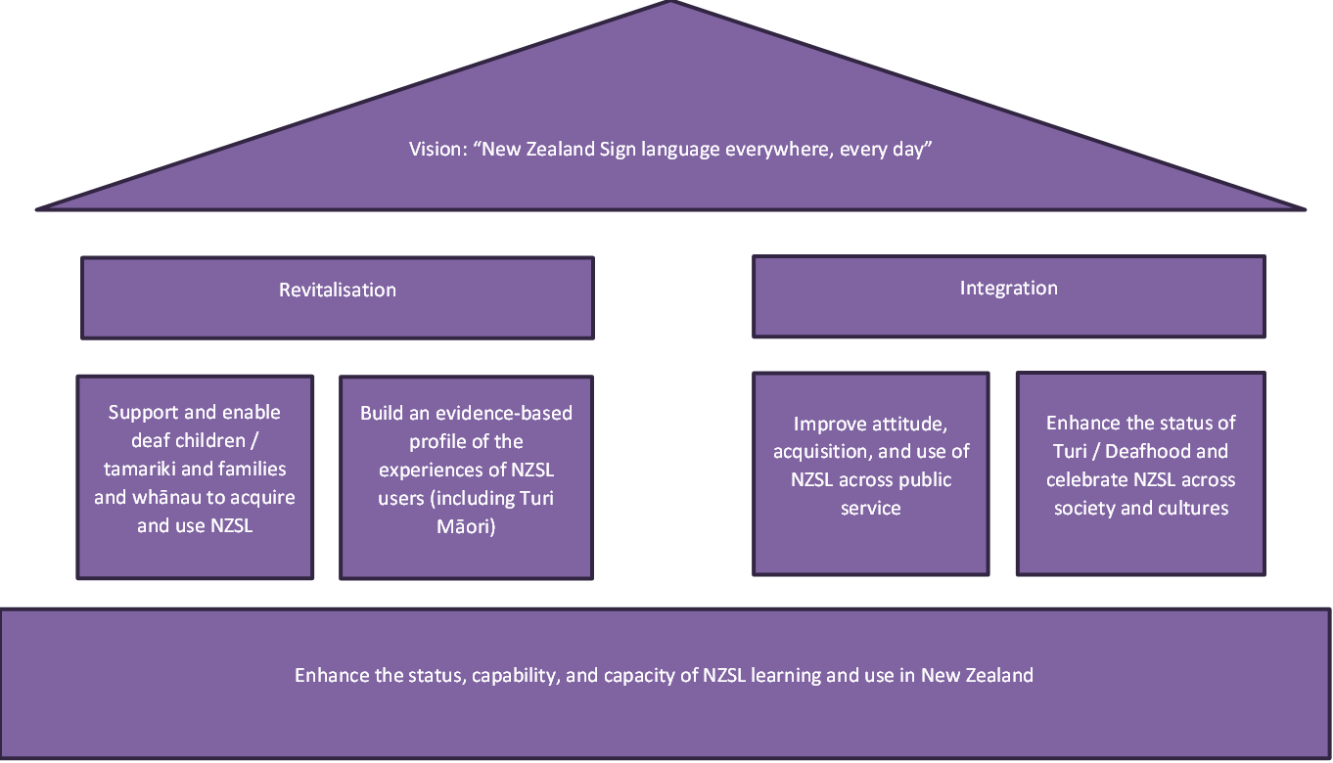

Priority work area 1

This priority area is to do with:
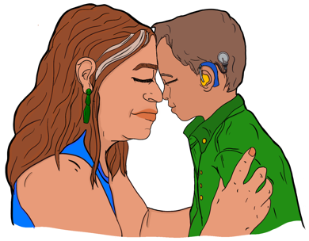
the revitalisation of NZSL
supporting deaf / hard of hearing tamariki / children to learn to use NZSL with their whānau / families
supporting communities to grow NZSL.

Proposed actions for priority work area 1

Here proposed means the work we think should be done to support each priority work area.

1 proposed action to grow NZSL is making language nests where:
people share what they know about NZSL
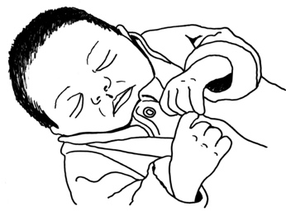
there are safe places for people:
- to learn NZSL
- to use NZSL
Deaf adults can share their knowledge about NZSL with:
- parents of deaf pēpē / babies
- deaf tamariki / children.

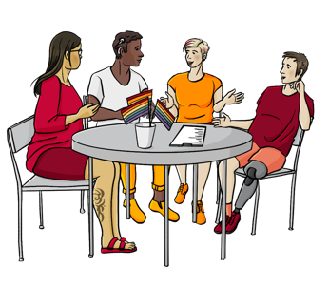
Here a language nest is a safe place people can learn NZSL with others.

Other proposed actions are doing things like:
making more time for
deaf / hard of hearing children and their whānau / families to learn together
making sure parents of deaf pēpē / babies and tamariki / children can get good NZSL:
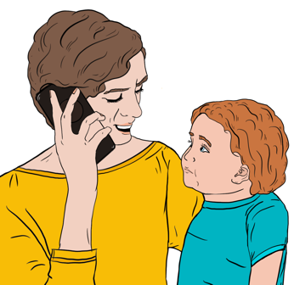
- information
- resources
- supports.

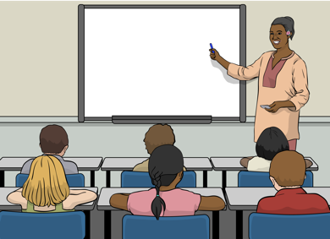
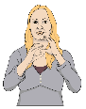
Other proposed actions are doing things like:
making sure deaf students:
- can use NZSL in the classroom
- have the resources they need in NZSL
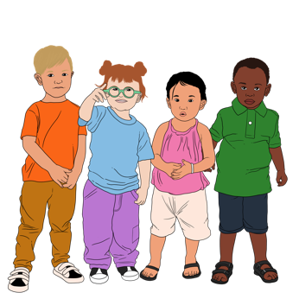
finding other learning opportunities to support:
- deaf tamariki / children
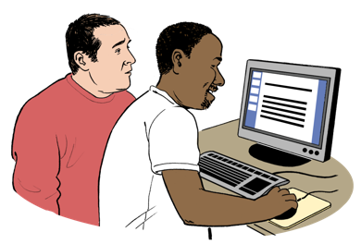
- Turi Māori to learn NZSL in
te ao Māori
growing NZSL learning opportunities.


An opportunity means when you have the chance to do something.

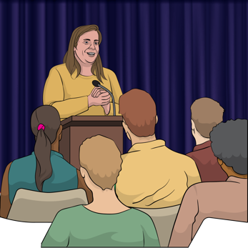
We also want to support people to become leaders who are:
Deaf
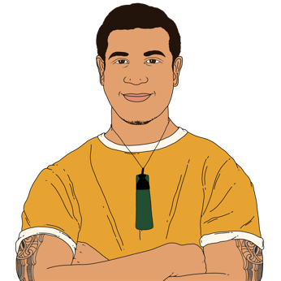
Turi Māori.

Priority work area 2

This priority area is to do with:

revitalisation
having good information about the lives of deaf / hard of hearing people.


This priority area is finding out information to support NZSL like:
doing research about NZSL
having evidence based resources to support:
- making the right resources to grow NZSL
- deaf / hard of hearing people to have better lives.

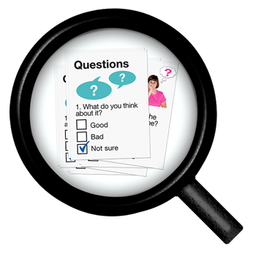
Evidence based is the information collected during research to find out things like if something:

works
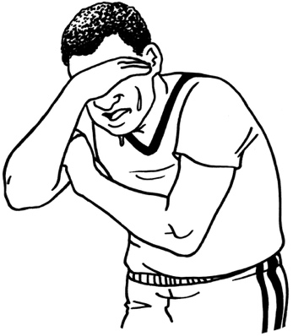
does not work
has happened
has not happened.

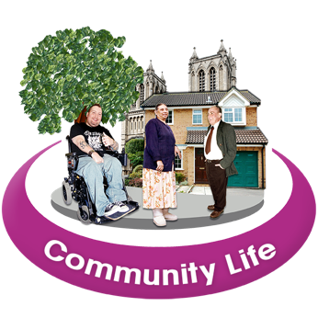
Having good information supports us to decide what to do about:
making more opportunities for people to take part in community life for:
- deaf / hard of hearing
- Turi Māori.

Having good information will support us to decide what to do about the problems deaf / hard of hearing people face in their day to day lives.

Proposed actions for priority work area 2

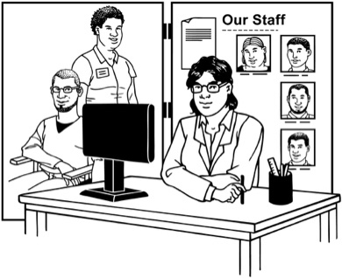
1 proposed action is finding the places where deaf NZSL users engage with government agencies to get things like:
health services
education services.

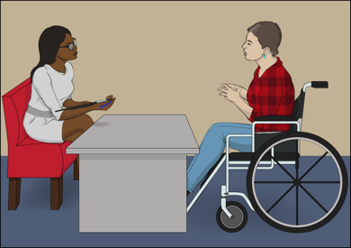
Here engage means when people contact a government agency about things they need like:

information
services
money.

Having this information will support us to find the:

gaps in the services
deaf / hard of hearing people can get when there is no NZSL
barriers deaf / hard of hearing people have when trying to get the services they need
if there are services
deaf people / Turi Māori need that are not in place yet.

We will need to make a way to check the progress made by government agencies to see if they are following the NZSL Strategy.

Here progress means making things better for deaf / hard of hearing people by growing NZSL.

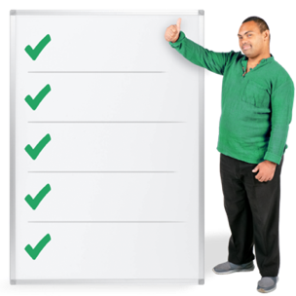
Checking progress made by government agencies will give us information to report on like:
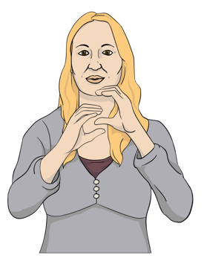
how many NZSL users are using government services
what things are being done to support NZSL users to engage with services
how well things are being done.

Priority work area 3

This priority area is to do with:
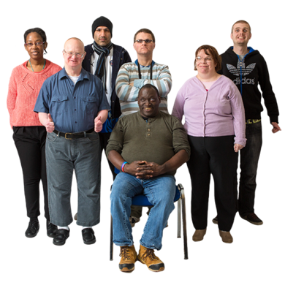
revitalisation
integration
making sure there is a workforce to support NZSL to grow.

Here workforce means the jobs people will need to do to support the growth of NZSL.

Work will have to be done to find out:
where support is needed to grow NZSL

what jobs will be needed to support NZSL
who will do these jobs.
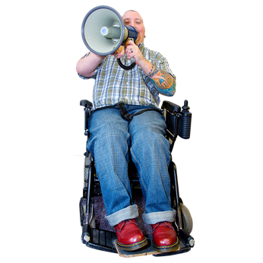
This means making opportunities to support people in the hearing community to:
know about NZSL
understand the importance of using NZSL
learn NZSL.

Proposed actions for priority work area 3

Proposed actions will be about deciding things like:
the people we need in our workforce like:
- Deaf teachers
- Turi Māori teachers
- NZSL teachers
- NZSL interpreters
the work needed to grow the NZSL workforce
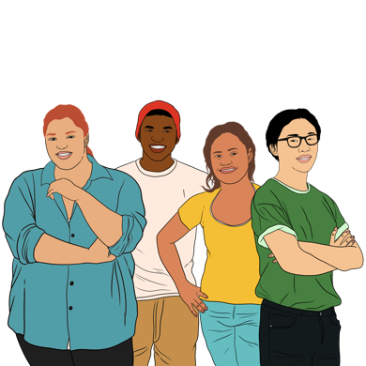
- the work needed to make sure Deaf people can get NZSL interpreters when they need them
- the work needed to grow NZSL in the hearing community.
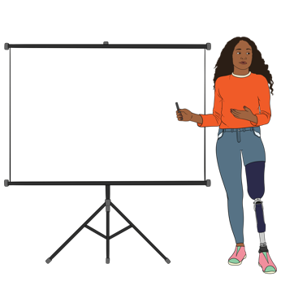
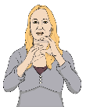
Work will also need to be done to decide how:
people can be trained to do these jobs
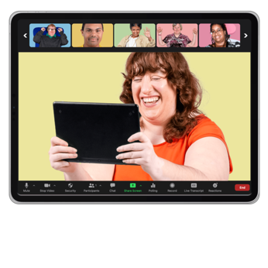
to support people in the hearing community to learn NZSL
technology can be used to support NZSL learning like:

- apps
- online courses.


Priority work area 4

This priority work area is about:
integration
what the Government should do to:
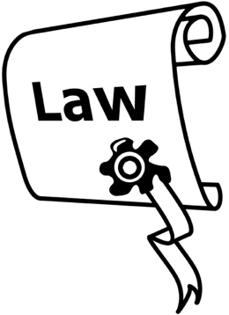
- support NZSL
- follow the New Zealand Sign Language Act 2006.

The New Zealand Sign Language Act is the law that:

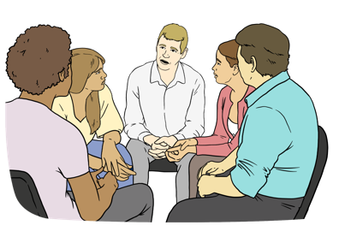
made NZSL an official language
guides government work about using NZSL.

A law is a rule made by the Government that everybody has to follow.

This means government agencies should follow the New Zealand Sign Language Act better.

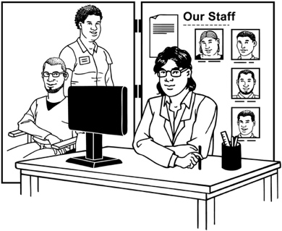
This will support deaf / hard of hearing people to get the services they need in a way they can understand.

Proposed actions for priority work area 4

Following the New Zealand Sign Language Act will mean government agencies should:
have staff who can use NZSL

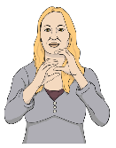
make sure things people need to know are in NZSL like their:
- information
- services.


Work will be needed to make more job opportunities for:
deaf / hard of hearing people
Turi Māori
NZSL users.

There should be staff at government agencies working with the public who can use NZSL.

Government agency staff should also have opportunities to learn about:
NZSL to support the Deaf community
Deaf culture.

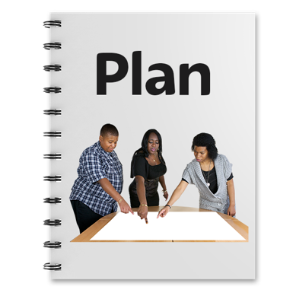
Other things government agencies should do are:
set out how they are going to use NZSL in their work plans
make the way to fund NZSL interpreters easier
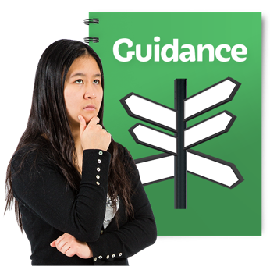
make a guide about how government agencies use NZSL interpreters.

Priority work area 5

This priority work area is about:

integration
celebrating NZSL
building role models in the Deaf and Turi Māori communities.

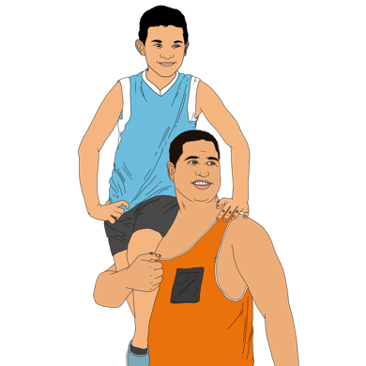

Here a role model is someone:
you look up to
who is very good at using NZSL.

2006
It is nearly 20 years since the NZSL Act was made a law.

This is a good time to promote NZSL to support everyone to use NZSL every day.

Here promote means the different ways to let people know about something like putting information:
in magazines
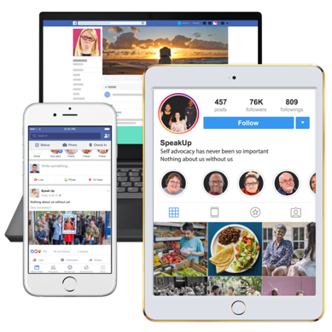
on social media
in government agency newsletters
on the TV.

Proposed actions for priority work area 5

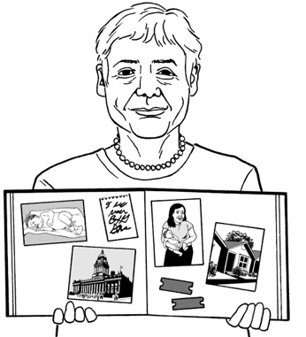
There are actions we can take to support this priority work area like:
writing stories about deaf people / Turi Māori
promoting NZSL in the hearing community
putting stories in the media about Deaf culture
making some events in 2026 to celebrate the anniversary of the
New Zealand Sign Language Act

making more NZSL resources for:
- the Deaf community
- te ao Māori.

Action plan

We will make an action plan to:
say what work we need to do in each priority work area of the NZSL Strategy
decide when this work should be done by.
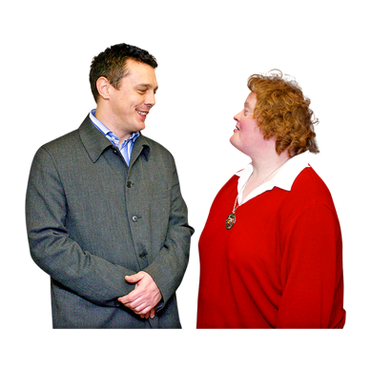

We understand we will need a lot of support to grow NZSL.

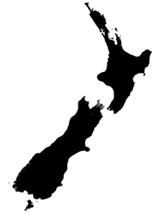
We will need support from:
government agencies
local government
communities like:
- deaf people
- Turi Māori
- deafblind people
- hearing people
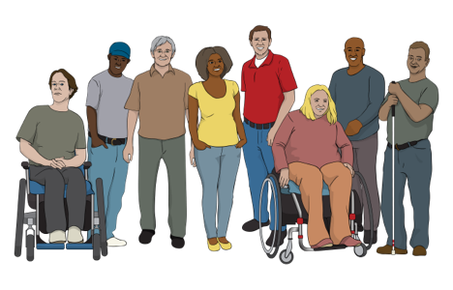
the NZSL workforce
businesses
everyone.

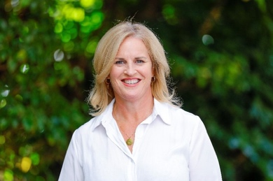
The NZSL Board makes a report every year for the Minister for Disability Issues.

The report tells the Minister about how well the NZSL Strategy is being followed.

We would like reports from government agencies to the Minister for Disability Issues about how well they are following the:
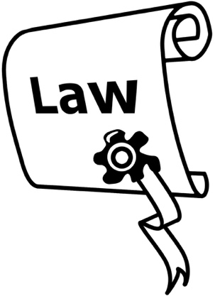
NZSL Strategy
New Zealand Sign Language Act 2006.

The NZSL Board will also work with government agencies to make sure they report on NZSL in their
annual / yearly report.
This can be about things like how government agencies:
are using NZSL to deliver their services
find out how many NZSL users are using their services.

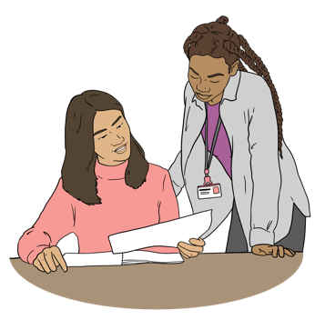
We will also need to find ways of checking that progress is made on the work set out in the action plan for the NZSL Strategy.

We will work with the Ministry for Disabled People – Whaikaha to support government agencies to do this.

We will need to find out things like:
what information we already have about NZSL
what information we need to know about NZSL

how we want NZSL to be used in the future.

How to send your feedback to us

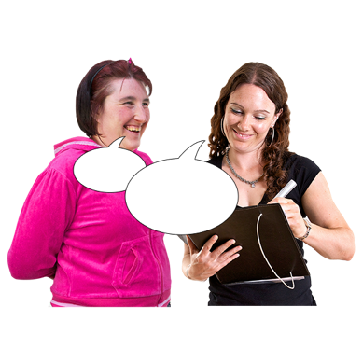
This part of the document tells you how to give us your feedback about the NZSL Strategy.

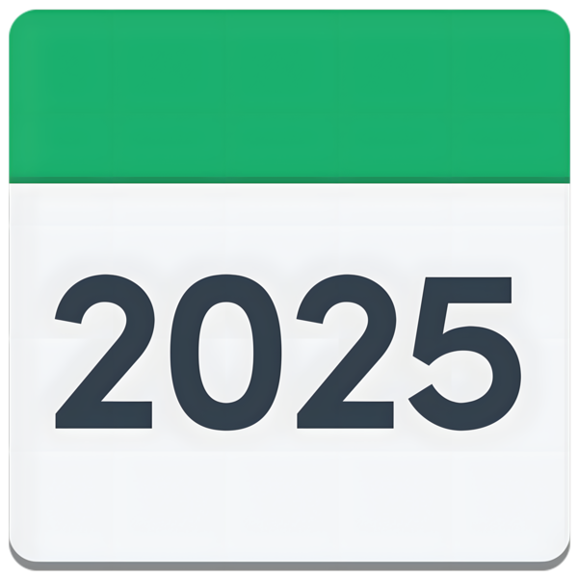
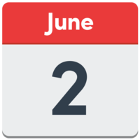
The closing date to send us your feedback is 2 June 2025.

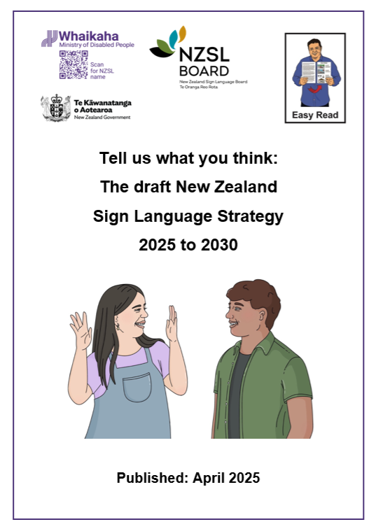
You can read our document Tell us what you think: The draft New Zealand Sign Language Strategy 2025 to 2030 at this website:

www.nzsl.govt.nz

This document has questions to support you to make your feedback.

You can give us feedback by going to:
in person meetings
online meetings.

You can find out more information about these meetings at the
NZSL Board website:
www.nzsl.govt.nz

You can also give us your feedback in:
NZSL in a video
writing.


You can send us a copy of your answers to our questions.

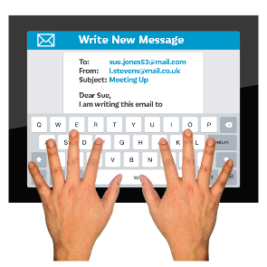
Send your feedback to this email address:

nzsl_strategy@whaikaha.govt.nz

You can also complete an online form at this website:

www.nzsl.govt.nz

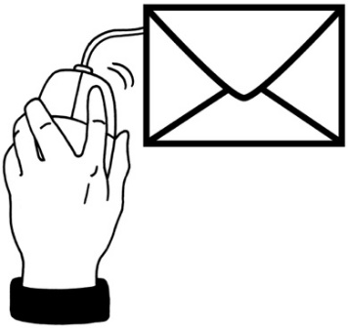
You can email the NZSL team for more information about the consultation process here:
nzsl_strategy@whaikaha.govt.nz

This information has been written by the NZSL Board and the Ministry of Disabled People – Whaikaha.

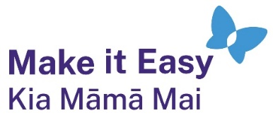
It has been translated into Easy Read by the Make it Easy Kia Māmā Mai service of People First New Zealand Ngā Tāngata Tuatahi.

The ideas in this document are not the ideas of People First New Zealand Ngā Tāngata Tuatahi.

All images used in this Easy Read document are subject to copyright rules and cannot be used without permission.

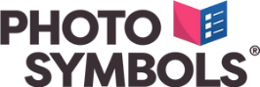
Make it Easy uses images from:

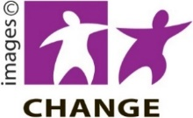
- Photosymbols

- Change Images


- Huriana Kopeke-Te Aho

- SGC Image Works

- T Wood

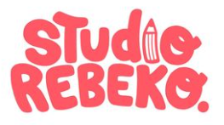
- Studio Rebeko

- Inga Kramer.

